**Quiz for Java Programming** (Tutor: cyd@bupt.edu.cn)

Unit05-Exceptions and Assertions

1. Syntax errors can be detected by IDE ; runtime errors can be detected by JVM ; logic errors can be detected by Programmer ;
2. F[T/F] If an exception occurs in a try clause, the rest lines in the try clause are skipped and the control is transferred to the main() function.
3. Error class inherits from Throwable class
4. T[T/F] An Error indicates serious problems that a reasonable application should try to catch.
5. runtimeexception, errorand their subclasses are known as unchecked exceptions.
6. T[T/F]Checked exceptions means that the compiler forces the programmer to check and deal with the exceptions.
7. Write a program. 1) Reads two numbers then divide one by another; If the divisor is zero, throw an ArithmeticException object. 2) Modify the program and put the division into a separate function; Test the function.

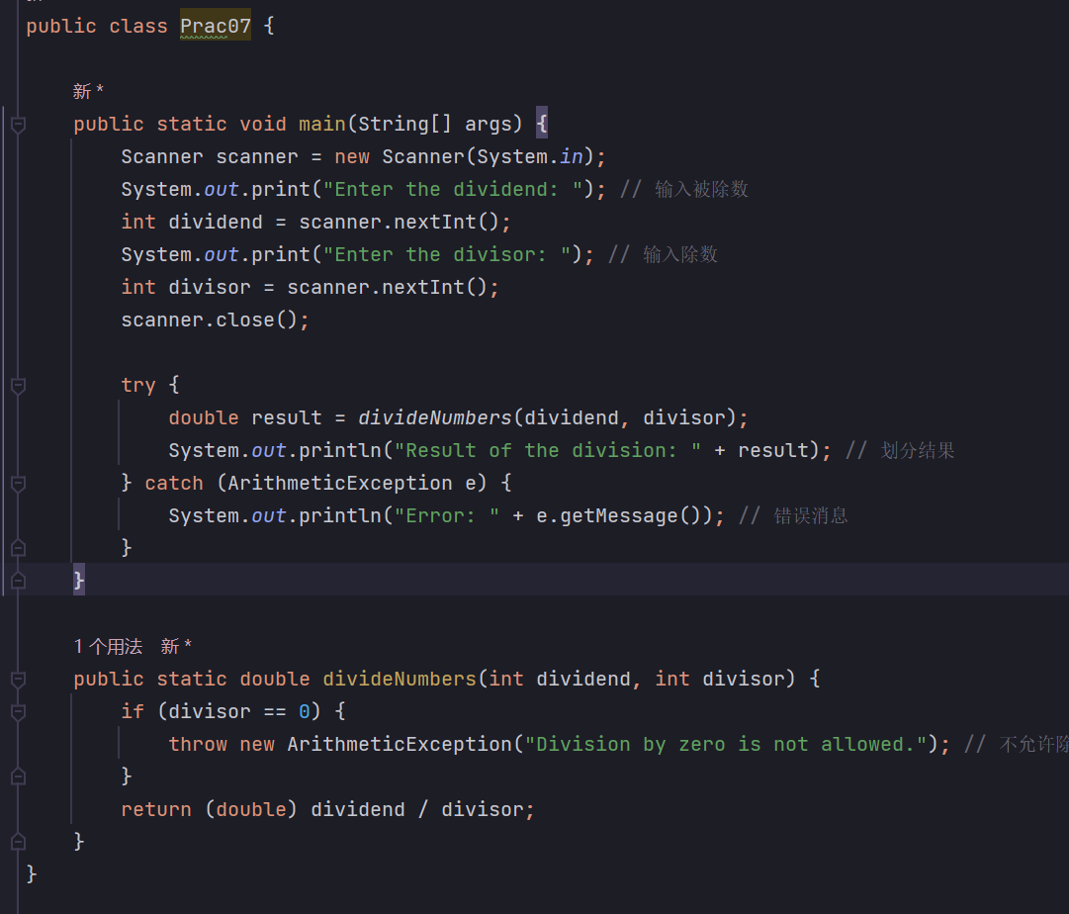

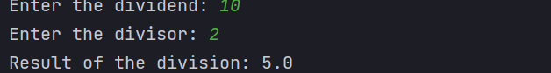



1. Based on quiz7, create a custom exception class to represent the situation of divisor being zero. There should be on string member in this class. Test your exception class against the ArithmeticException class.

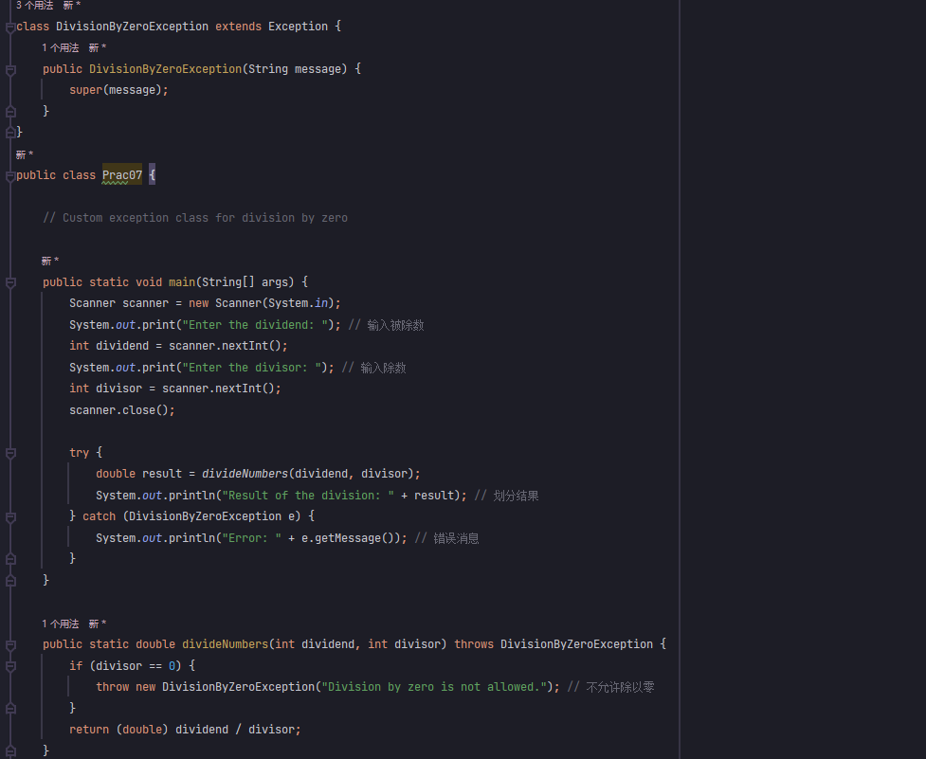

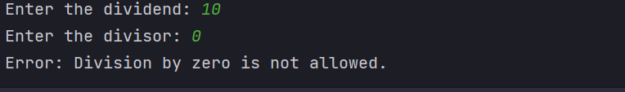

1. Based on quiz8, catch all the exceptions.

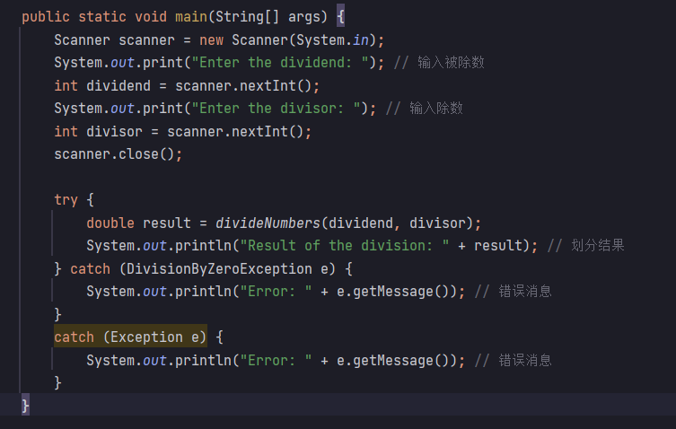

1. Based on quiz9, output information with finally clause.

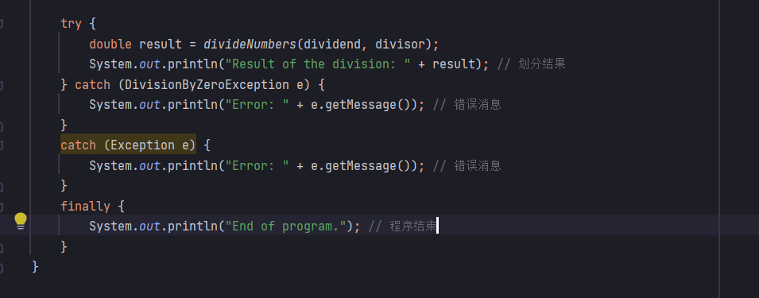

1. Based on quiz10, add a new function setDivisor() to modify the divisor. In setDivisor(), use assertions to test if the divisor is zero..

注意,需要在运行java的时候选择-ea选项来开启断言才能进行

